Name___________________________________.

|  |  |  |
| --- | --- | --- |
| Test part | Possible mark | Your mark |
| Multiple choice | 15 |  |
| Short answer | 45 |  |
| Total | 60 |  |

HUMAN BIOLOGICAL SCIENCE. YEAR 12. 2014.

Immunity, Muscles, Bones and Joints.

***Multiple choice answer sheet.***

**Use a ball point or ink pen to mark an X** on the letter that represents the best answer from the choice of answers . Marks are not deducted for wrong answers.

|  |  |
| --- | --- |
| Question | Answer |
| 1 | A B C D |
| 2 | A B C D |
| 3 | A B C D |
| 4 | A B C D |
| 5 | A B C D |
| 6 | A B C D |
| 7 | A B C D |
| 8 | A B C D |
| 9 | A B C D |
| 10 | A B C D |
| 11 | A B C D |
| 12 | A B C D |
| 13 | A B C D |
| 14 | A B C D |
| 15 | A B C D |

Multiple Choice

1. Which of these is the explanation of how muscles contract?   
a. Lock and Key Hypothesis   
b. Cell Theory   
c. Mendel’s laws   
d. Sliding filament model

2. Which of the following ions move into muscle fibers during muscle contraction?   
a.   Sodium   
b.  Calcium   
c.  Phosphate   
d.  Potassium

3. What are the actin and myosin structures in muscle composed of?

a. Nucleic acids   
b. Fatty acids   
c. Proteins   
d. Carbohydrates

4. The Matrix in cartilage tissue is made of which of the following materials?

a. Collagen.

b. Calcium Phosphate.

c. Calcium sulphate.

d. Adipose tissue.

5. All connective tissue contains which of the following?

a. A suspensor fluid.

b. A matrix.

c. A hard framework.

d. A set of unconnected cells.

6. The osteocytes in dense bone tissue are interconnected with each other by which of the following?

a. The Haversian system.

b. arteries.

c. veins.

d. Canaliculi.

7. One of the functions of the Periosteum is:

a. To provide a place of attachment for tendons.

b. To insulate the bone.

c. To reduce Friction.

d. All of the above.

8. Movement of the elbow joint can be:

a. Circumduction.

b. flexion and extension.

c. Abduction only.

d. Adduction only.

9. If the rate of osteoclast activity is much greater than osteoblast activity:

a. The bone will become less dense and much weaker.

b. The bone will become denser and much stronger.

c. The bone will become denser, yet more brittle.

d. The osteocytes will starve.

10. Which of the following is **not** a function of the skeletal system?

a. Storage of digestive enzymes.

b. Protection of internal organs.

c. Support against gravity.

d. Production of blood cells.

1. The antibodies that a baby receives from its mother are an example of:
2. Natural passive immunity.
3. Artificial passive immunity.
4. Natural active immunity.
5. Artificial active immunity.
6. Vaccination using attenuated antigens is an example of:
7. Natural passive immunity.
8. Artificial passive immunity.
9. Natural active immunity.
10. Artificial active immunity.

13 Which of the following is not found in the CSF?

1. Urea
2. White blood cells
3. Glucose
4. Acetylcholine

Use the diagram below to answer questions 14 and 15.

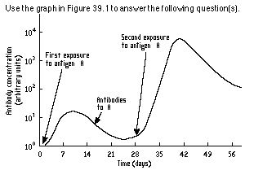

1. Why does the antibody concentration between 21 and 28 days **not** drop back to zero?
2. Memory T cells carry antibodies able to respond to antigen A.
3. Killer T cells carry antibodies able to respond to antigen A.
4. Memory B cells carry antibodies able to respond to antigen A.
5. Plasma B cells carry antibodies able to respond to antigen A.
6. The response to antigen A at 28 days would result in:
7. A rapid response and little or no symptoms of infection.
8. A reduction in T cells, but an increase in B cells.
9. Similar symptoms as seen in days 0 to 14.
10. A new set of antigens being produced.

Short Answer Questions

1. Label the following diagram.

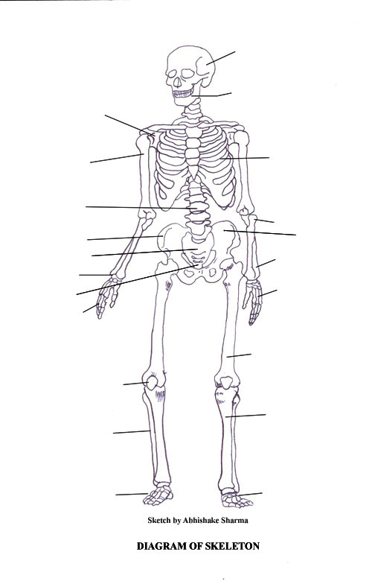

(5 marks)

One mark will be subtracted for each error

1. In the immune response a macrophage sensitizes a B white blood cell to an antigen. What would happen next in the Humoral (antibody) response?

______________________________________________________________________________________________________________________________________________________________________________________________________________________________________________________________________________________________________________________________________________________________________________________________________________________________________________________________________________________________________________________________________________________________________________________________________________________________________________________________________________________________________________________________________________________________________________________________________________________________________________________________________________________________________________________________________________________________________________________________________

(5 marks)

1. Complete this table

|  |  |
| --- | --- |
| Word | Meaning |
| Muscle insertion |  |
| Muscle origin |  |

(2 marks)

1. Complete this table

|  |  |  |
| --- | --- | --- |
| Type of joint | Description | Example |
| Fibrous |  |  |
| Cartilaginous |  |  |
| Synovial |  |  |

(6 marks)

1. Here is a diagram of a synovial joint. Label it and then complete the table that follows.

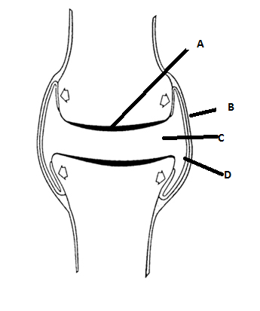

(2 Marks)

II.

|  |  |
| --- | --- |
| Structure | Function |
| A |  |
| B |  |

(2 marks)

III.

Raymond was a keen long distance runner. He was disappointed to be told that he had wear on the articulating cartilage of his right knee due to many years of running. What is the name of the disorder he has. Why will it cause problems. What are the symptoms and how can it be treated?

(8 marks)

___________________________________________________________________________________________________________________________________________________________________________________________________________________________________________________________________________________________________________________________________________________________________________________________________________________________________________________________________________________________________________________________________________________________________________________________________________________________________________________________________________________________________________________________________________________________________________________________________________________________________________________________________________________________________________________________________________________________________________________________________________________________________________________________________________________________________________________________________________________________________________________________________________________________________________________________________________________________________________________________

1. Use the diagram of microscopic bone structure below to complete the empty boxes in the table below it.

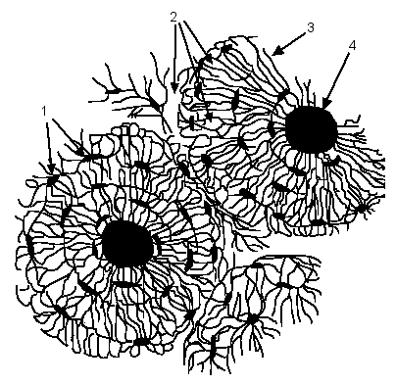

|  |  |  |
| --- | --- | --- |
| Label number | Name of part or material | Function |
| 1 | Osteocytes in Lacunae | Mature bone cells that maintain bone tissue. |
| 2 | Hard matrix |  |
| 3 |  |  |
| 4 |  |  |

(5 Marks)

1. Briefly describe what is happening in the diagram below.

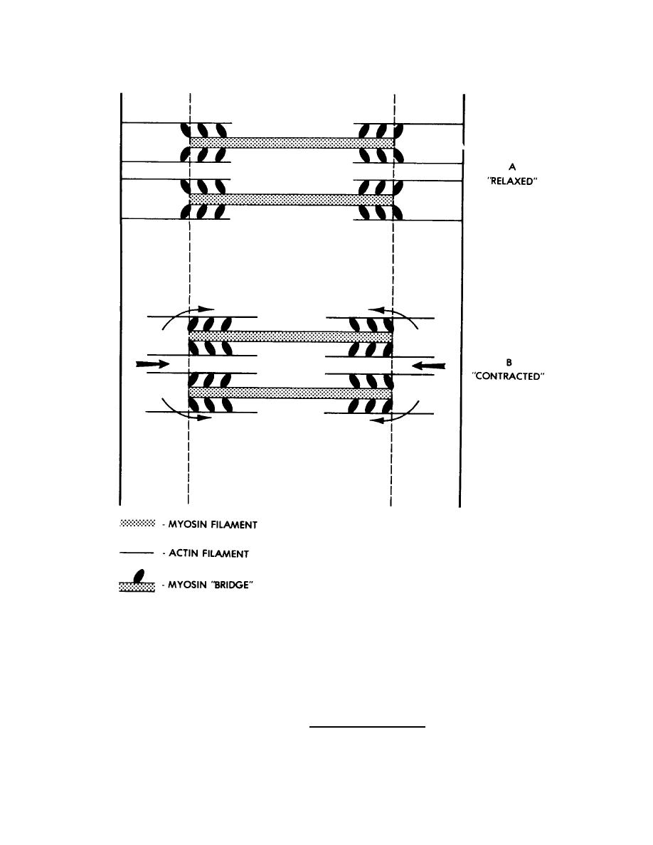

______________________________________________________________________________________________________________________________________________________________________________________________________________________________________________________________________________________________________________________________________________________________________________________________________________________________

(4 marks)

1. Complete the table below.

|  |  |  |
| --- | --- | --- |
| Type of synovial joint | Movement | Example |
| Ball and socket |  |  |
| Hinge |  |  |

(4 marks)

End of Test